LRDI class 3 : Ratio and percentages

https://www.facebook.com/events/2091060721130287/

watch the concept of basic terminology usually asked in typical DI SETS.

https://www.youtube.com/watch?v=3HbpbZcPVl0&feature=youtu.be

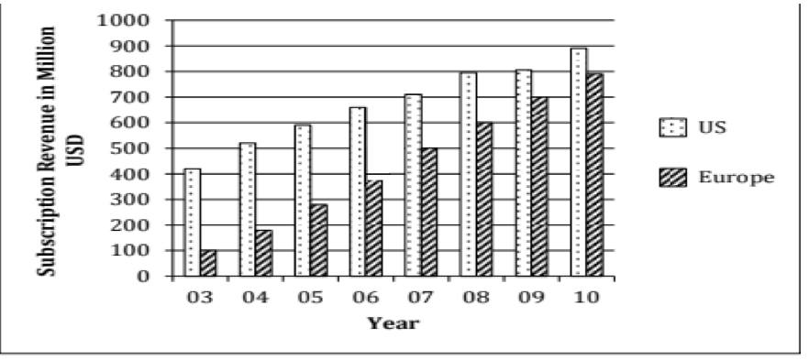

While the subscription in Europe has been growing steadily towards that of the US, the growth rate in Europe seems to be declining. Which of the following is closest to the percentage change in growth rate of 2007(over 2006) relative to the growth rate of 2005 (over 2004)?  
(1) 17   
(2) 20   
(3) 35   
(4) 60

The difference between the estimated subscription in Europe in 2008 and what it would have been if it were computed using the percentage growth rate of 2007 (over 2006), is closest to:  
(1) 50  
(2) 80   
(3) 20   
(4) 10

n 2003, sixty percent of subscribers in Europe were men. Given that woman subscribers increase at the rate of10 percent per annum and men at the rate of 5 percent per annum, what is the approximate percentage growth of subscribers between 2003 and 2010 in Europe? The subscription prices are volatile and may change each year.  
(1) 62   
(2) 15   
(3) 78  
(4) 84   
(5) 50.

Consider the annual percent change in the gap between subscription revenues in the US and Europe. What is the year in which the absolute value of this change is the highest?(1) 03-04   
(2) 05-06   
(3) 06-07   
(4) 08-09  
(5) 09-10

Soln : https://www.youtube.com/watch?v=9vynOgTqyc4&feature=youtu.be

The proportion of male students and the proportion of vegetarian students in a school are given below. The school has a total of 800 students, 80% of whom are in the Secondary Section and rest equally divided between Class 11 and 12.

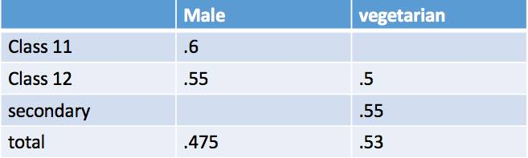

In the Secondary Section, 50% of the male students are vegetarian. Which of the following statements is correct?  
1.Except vegetarian males, all other groups have same number of students.  
2.Except non-vegetarian males, all other groups have same number of students.  
3. Except vegetarian females, all other groups have same number of students.  
4.Except non-vegetarian females, all other groups have same number of students  
5.All of the above groups have the same number of students.

In Class 12, twenty five per cent of the vegetarians are male. What is the difference between the number of female vegetarians and male non-vegetarians?  
(1) less than 8 (2) 10 (3) 12(4) 14 (5) 16.

In the Secondary Section, 50% of the male students are vegetarian. Which of the following statements is correct?  
1.Except vegetarian males, all other groups have same number of students.  
2.Except non-vegetarian males, all other groups have same number of students.  
3. Except vegetarian females, all other groups have same number of students.  
4.Except non-vegetarian females, all other groups have same number of students  
5.All of the above groups have the same number of students.

Similar question set : https://www.youtube.com/watch?v=8Dxn_pqWr_w&feature=youtu.be

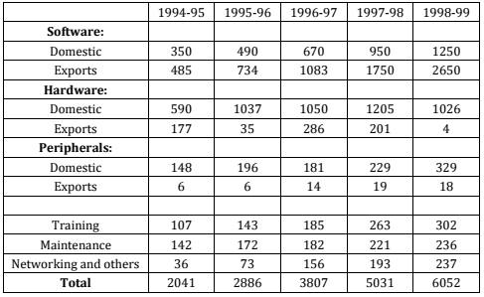

Q1.The total annual exports lay between 35 and 40 percent of the total annual business of the IT industry, in years  
1.1997-98 and 1994-95  
2.1996-97 and 1997-98  
3.1996-97 and 1998-99  
4.1996-97 and 1994-95.

Q2.highest percentage growth in the total IT business, relative to the previous year was achieved in  
(1) 1995-96(2) 1996-97(3) 1997-98(4) 1998-99

Q3. Which one of the following statements is correct?  
(1)The annual software exports steadily increased but annual hardware exports steadily declined during1994-1999.  
(2) The annual peripheral exports steadily increased during 1994-1999.  
(3) The total IT business in training during 1994-1999 was higher than the total IT business in maintenance during the same period.  
(4) None of the above statements is true.

https://www.youtube.com/watch?v=PYmiUXuOlSk&feature=youtu.be